Deep Learning
5. Recurrent Neural Networks (RNN)
5.1 Sequence Learning Problem, Unfolding Computational graphs, Recurrent Neural Network, Bidirectional RNN, Backpropagation Through Time (BTT), Limitation of “vanilla RNN” Vanishing and Exploding Gradients, Truncated BTT.
5.2 Long Short-Term Memory (LSTM): Selective Read, Selective write, Selective Forget, Gated Recurrent Unit (GRU).
PAST QUESTIONS:
- Describe sequence learning problem. (D23)
- Explain Gated Recurrent Unit in detail. (D23)
- Explain RNN architecture in detail. (D23)
- Explain LSTM architecture. (D23)
- Explain vanishing and exploding gradient in RNNs. (D23)
- Explain LSTM model, how it overcomes the limitation of RNN. (M24)
- Difference between the architecture of LSTM and GRU network. (D24)
- Explain the key components of an RNN. (D24)
- Difference between the LSTM and GRU network. (M25)
- Explain the working of RNN with the help of a suitable diagram. (M25)
- Explain how Recurrent Neural Networks (RNNs) are suited for sequential data. Compare the standard RNN architecture with Long Short-Term Memory (LSTM) networks in terms of their ability to handle long-term dependencies. Provide a real-world application where using an LSTM would be significantly more beneficial than a simple RNN and justify your reasoning. (M25)

NOTES:

*Sequence Learning Problem :-
*RNN :-
A recurrent neural network (RNN) is the type of artificial neural network (ANN) that is used in Apple’s Siri and Google’s voice search. RNN remembers past inputs due to an internal memory.
Recurrent Neural Networks (RNNs) differ from regular neural networks in how they process information. While standard neural networks pass information in one direction i.e. from input to output, RNNs feed information back into the network at each step.
Imagine reading a sentence and you try to predict the next word, you don’t rely only on the current word but also remember the words that came before. RNNs work similarly by “remembering” past information and passing the output from one step as input to the next i.e it considers all the earlier words to choose the most likely next word. This memory of previous steps helps the network understand context and make better predictions.
Key components of RNN –
There are mainly two components of RNNs
1. Recurrent Neurons: The fundamental processing unit in RNN is a Recurrent Unit. They hold a hidden state that maintains information about previous inputs in a sequence.
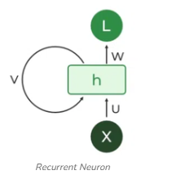
The input layer X processes the initial input and passes it to the middle layer H. The middle layer consists of multiple hidden layers, each with its activation functions, weights, and biases. These parameters are standardized across the hidden layer so that instead of creating multiple hidden layers, it will create one and loop it over.
Instead of using traditional backpropagation, recurrent neural networks use backpropagation through time (BPTT) algorithms to determine the gradient where instead of updating weights based only on the current timestep t, we also consider all previous timesteps i.e, t-1, t-2, t-3…
2. RNN Unfolding: RNN unfolding or unrolling is the process of expanding the recurrent structure over time steps. During unfolding each step of the sequence is represented as a separate layer in a series illustrating how information flows across each time step.
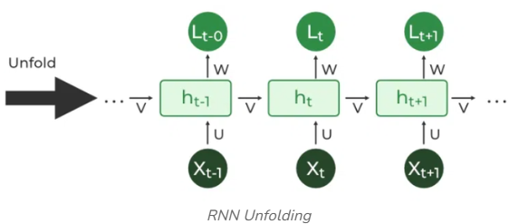
There are four types of RNN based on different lengths of inputs and outputs.
- One-to-one is a simple neural network. It is commonly used for machine learning problems that have a single input and output.
- One-to-many has a single input and multiple outputs. This is used for generating image captions.
- Many-to-one takes a sequence of multiple inputs and predicts a single output. It is popular in sentiment classification, where the input is text and the output is a category.
- Many-to-many takes multiple inputs and outputs. The most common application is machine translation.
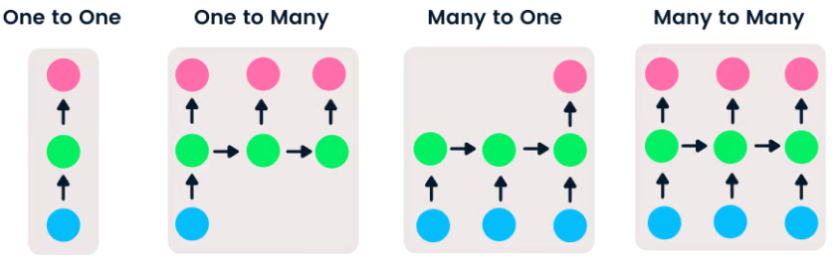

*Issues :-
Issues of Vanilla RNNs:
Vanishing and Exploding Gradients -
During the training of neural networks, gradients are used to update the weights. However, in RNNs, when gradients are backpropagated through time, they can either shrink exponentially (vanish) or grow exponentially (explode), leading to the vanishing gradient problem or exploding gradient problem respectively.
The vanishing gradient problem makes it difficult for the RNN to learn and tune the parameters for the early layers in the network, making it hard for the RNN to capture long-term dependencies in the data. On the other hand, exploding gradients can lead to unstable and inefficient learning.
Short-term Memory of Vanilla RNNs –
Due to the vanishing gradient problem, vanilla RNNs tend to have a “short-term memory”, i.e., they can struggle to maintain the influence of information from earlier time steps as the sequence gets longer.
While they can typically handle short sequences relatively well, their performance can degrade for longer sequences.
This is a significant limitation as many sequential tasks involve important dependencies over varying time scales.

*LSTM :-
Standard Recurrent Neural Networks (RNNs) suffer from short-term memory due to a vanishing gradient problem that emerges when working with longer data sequences.
Luckily, we have more advanced versions of RNNs that can preserve important information from earlier parts of the sequence and carry it forward. The two best-known versions are Long Short-Term Memory (LSTM) and Gated Recurrent Units (GRU).
A traditional RNN has a single hidden state that is passed through time, which can make it difficult for the network to learn long-term dependencies.
LSTMs address this problem by introducing a memory cell, which is a container that can hold information for an extended period of time.
The LSTM consists of units that are known as gates. They control the flow of information in and out of the memory cell or LSTM cell.
The memory cell is controlled by three gates: the input gate, the forget gate, and the output gate. These gates decide what information to add to, remove from, and output from the memory cell.
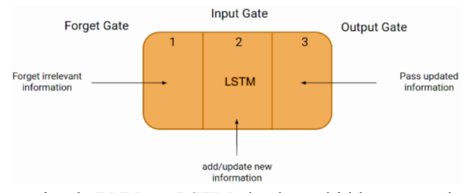
The LSTM network architecture consists of three parts, as shown in the image above, and each part performs an individual function.
The first part chooses whether the information coming from the previous timestamp is to be remembered or is irrelevant and can be forgotten.
In the second part, the cell tries to learn new information from the input to this cell and updates the information.
At last, in the third part, the cell passes the updated information from the current timestamp to the next timestamp. This one cycle of LSTM is considered a single-time step.

*GRU :-
GRU or Gated recurrent unit is an advancement of the standard RNN i.e recurrent neural network. It was introduced by Kyunghyun Cho et al in the year 2014.
GRUs are very similar to Long Short-Term Memory (LSTM). Just like LSTM, GRU uses gates to control the flow of information. They are relatively new as compared to LSTM. This is the reason they offer some improvement over LSTM and have simpler architecture.
Another Interesting thing about GRU is that, unlike LSTM, nstead of using a “cell state” to regulate information, it uses hidden states. Due to the simpler architecture, GRUs are faster to train.
Now there are primarily two gates in a GRU as opposed to three gates in an LSTM cell. The first gate is the Reset gate and the other one is the update gate.
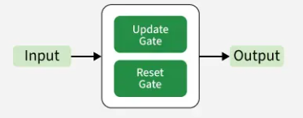
Update Gate - Determines how much of the past information should be kept for the current step.
Reset Gate – Controls how much of the past information to forget, helps the network reset memory when needed.

*LSTM vs GRU :-
